OPM - FACES Assembly
Deployment Guide

Revision History
Author | Revision Number | Date
TCSASSEMBLER | 1 | 3/1/2014

Deployment Instructions 3
1. Organization of Submission 3
2. Application Setup 3
3. Ant .Properties File 4
4. Build Scripts Setup 4
5. Database Setup 5
6. Deployment Instructions 6
7. Starting 6
8. Verification 7
8.1. Web Tests 7
9. Resource Contact List 15

Deployment Instructions

Organization of Submission

Folder | Description
conf | Contains application configuration files
lib | Contains dependencies
src | Contains all source files
docs | Contains documentation (this file)
test_files | Contains the test files
log | Contains the test log files
conf/jpa | Contains the JPA mapping and persistence configuration
conf/ejb | Contains the EJB configuration
conf/rules | Contains the business rule definitions
conf/web | Contains the web application configuration files (including spring MVC bean definitions)
conf/ear | Contains application wide configuration (including the datasource definition)
conf/jboss | Contains application changes to the JBoss configuration
src/web | Contains the web application sources
src/java/core | Contains java sources shared across modules
src/java/ejb | Contains java sources for the EJB module
src/java/web | Contains java sources for the front end web application
src/java/tests | Contains java test sources
build-dependencies.xml | Declaration of build dependencies
build.properties | Externalized build configuration
build.xml | Ant build script

Application Setup

The application is tested with the following stack

- Java 6 (http://www.oracle.com/technetwork/java/javase/downloads/index.html)
- JBoss EAP 6.1 (http://www.jboss.org/jbossas/downloads/)
- Ant 1.8.1 (http://ant.apache.org/)
- PostgreSQL 9.2.4 (http://www.postgresql.org/)

The following 3rd party libraries are packaged with the submission
- Drools 5.5
- Jackson 2.3.1
- Spring MVC 3.2.3
- Spring Security 3.1.4
- Hibernate 4.2.3
- Joda-Time 2.3
- JUnit 4.10

Ant .Properties File

Property Name | File property is stored | Example Setting
jboss.home | build.properties | C:/Downloads/jboss-eap-6.1
loggerName | build.properties | gov.opm.scrd
supervisorRoleName | build.properties | supervisor
adminRoleName | build.properties | Admin
defaultPreferenceId | build.properties | 1
defaultReportGenerationDataId | build.properties | 1
log_dir | build.properties | C:/Downloads/opm_log
closedAccountStatusName | build.properties | Closed
openedAccountStatusName | build.properties | Active
redepositPeriodType.id | build.properties | 1
redepositPeriodType. name | build.properties | Deposit
dedepositPeriodType.id | build.properties | 2
dedepositPeriodType. name | build.properties | Redeposit
csrsRetirementType.id | build.properties | 2
csrsRetirementType. name | build.properties | CSRS
successCalculationStatus.id | build.properties | 1
successCalculationStatus. name | build.properties | Success
db.driver | build.properties | org.postgresql.Driver
db.url | build.properties | jdbc:postgresql://localhost:5432/scrd
db.user | build.properties | postgres
db.pass | build.properties | 123456

Build Scripts Setup

build.xml – compiles, packages and deploys the application
Main targets:

clean removes all generated files
compile-core compiles shared java sources
compile_tests compiles java test sources
test run the test cases
compile-ejb compiles EJB java sources
compile-war compiles web application java sources
configure-ear performs replacement of values for EAR configuration files
configure-ejb performs replacement of values for EJB configuration files
configure-war performs replacement of values for web app configuration files
db-clear clears the contents of the tables
db-create creates the tables and sequences
db-drop drops the tables and sequences
db-test-data recreates the test data
deploy deploys the EAR artifact
deploy-jdbc-driver copies the jdbc driver module into jboss
dist-core creates the core distribution
dist-ear creates the EAR artifact
dist-ejb creates the EJB distribution
dist-war builds the war file

Default target: deploy

Database Setup

Note: for some steps, you can use the ant script to execute them, but make sure you configure the build.properties first.

- Setup PostgreSQL 9.2.4
- Create the database “scrd” using your client. (You may change the DB name, but update your JDBC URL accordingly)

- Execute script src/sql/create-schema.sql and src/sql/triggers.sql to create the required objects (“ant db-create” will perform the same step)
- Execute script ant “db-test-data” to insert test data

Setup Database Driver module on JBoss

- Copy conf/jboss/modules into the modules folder of your EAP installation -${jboss.home}/modules/system/layers/base (“ant deploy-jdbc-driver” will perform the same step)
- Add the following entry to ${jboss.home}/standalone/configuration/standalone.xml just after the h2 driver declaration on the datasources/drivers subsystem

<driver name="postgresql-jdbc4" module="org.postgresql">
<driver-class>org.postgresql.Driver</driver-class>
</driver>

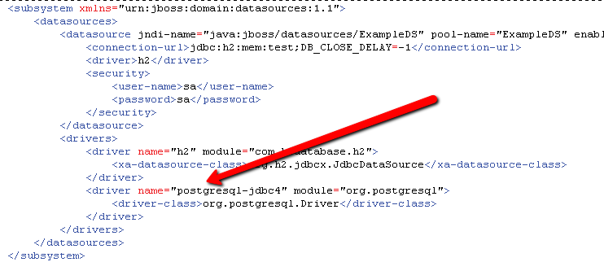

Note: This step can also be done via the jboss command line interface with the following command:

/subsystem=datasources/jdbc-driver=postgresql-jdbc4:add(driver-name=postgresql-jdbc4, driver-class-name=org.postgresql.Driver, driver-module-name=org.postgresql)

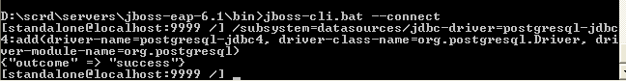

Cleanup scripts: (execute only when done with testing)
• When needed, execute src/sql/clear-data.sql to clear the database tables (“ant db-clear” will perform the same step)
• When needed, execute script src/sql/drop-schema.sql to delete all application objects (“ant db-drop” will perform the same step)

Deployment Instructions

- Modify build.properties to reflect the deployment environment settings. (log_dir must be an existing directory)
- Setup the database as described in the previous section
- Execute “ant deploy”

Starting

Start JBoss. The application is automatically started when the JBoss server is started.

Please note that you may receive a warning (JBAS011054) regarding EAP 6.1 and Spring 3.2.3, you may safely ignore this warning per

https://community.jboss.org/thread/231638?start=0&tstart=0

Verification

Web Tests
When started, open the default URL in your browser http://localhost:8080/scrd/, this should show you the pages.

Note: you may want to turn on DEBUG logging on the server, just add following line to the server configuration (jboss-eap-6.1/standalone/configuration/standalone.xml) under the logging subsystem – make the changes the before starting the server:

<logger category="gov.opm.scrd">
<level name="DEBUG"/>
</logger>

Make sure you change the threshold of the appender to DEBUG too.

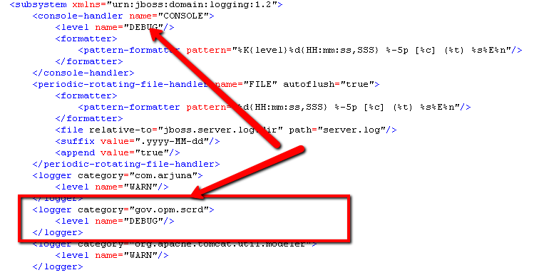

Login
1) Open http://localhost:8080/scrd, use “user1” and “123456” to login:
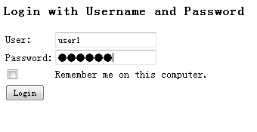

Search Account

click View Account, the search panel shows.
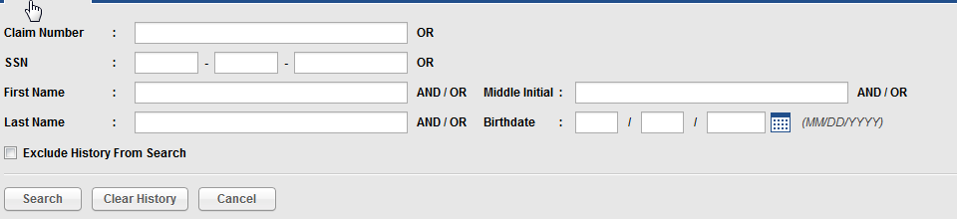

Enter criteria and click Search, the search result will show.
The search filter will enable 2 seconds after the user begin to input data.
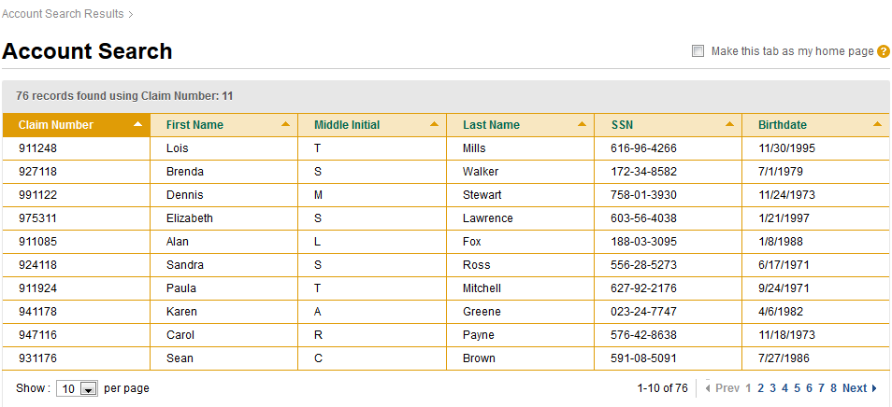
Click on any row will bring the user to the account detail page.

Click clear history button, the search history will be deleted from the session.
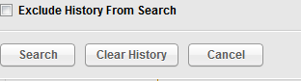

View Account Detail

Go to: http://localhost:8080/scrd/faces/1/detail
(use “user1” and “123456” to login if needed, see 8.1.1):
In the view account page you can consult the detail information about an account

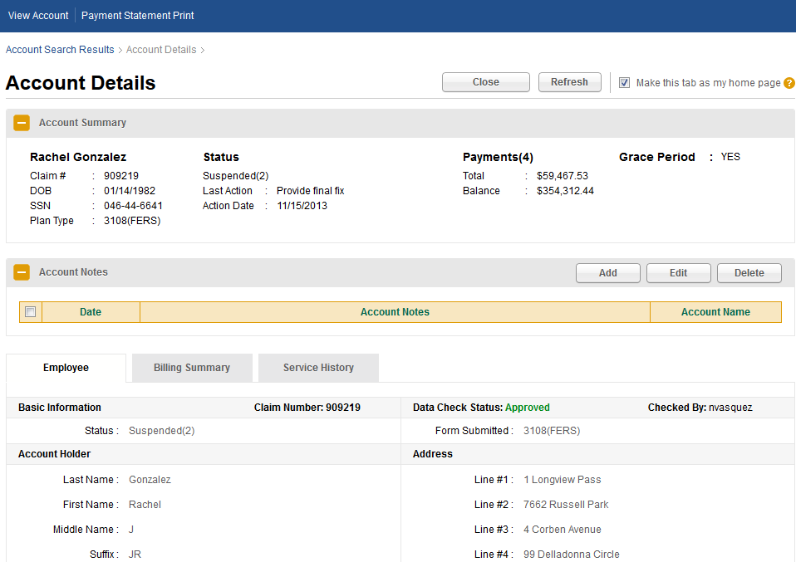

Close/Reopen Account
Click “Close” to close the account
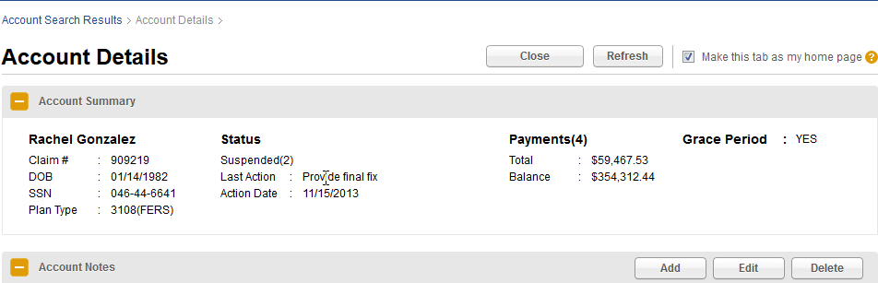
You will see the Status of account become “Closed”.
Now click on the “Reopen” button.
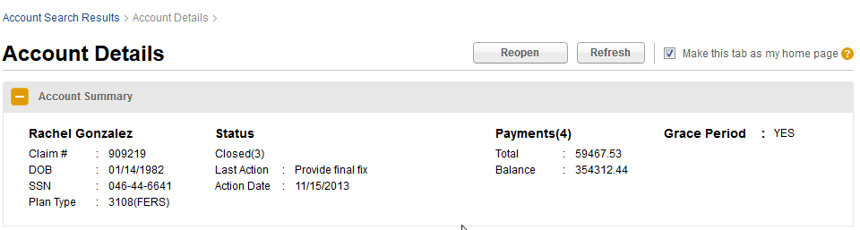
You will see the account status back to “Active”
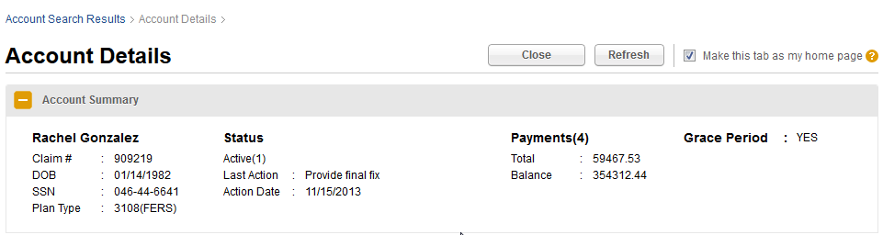

Update Account Change
Try to edit basic information, billing information, and service history tab, make change and save the data.
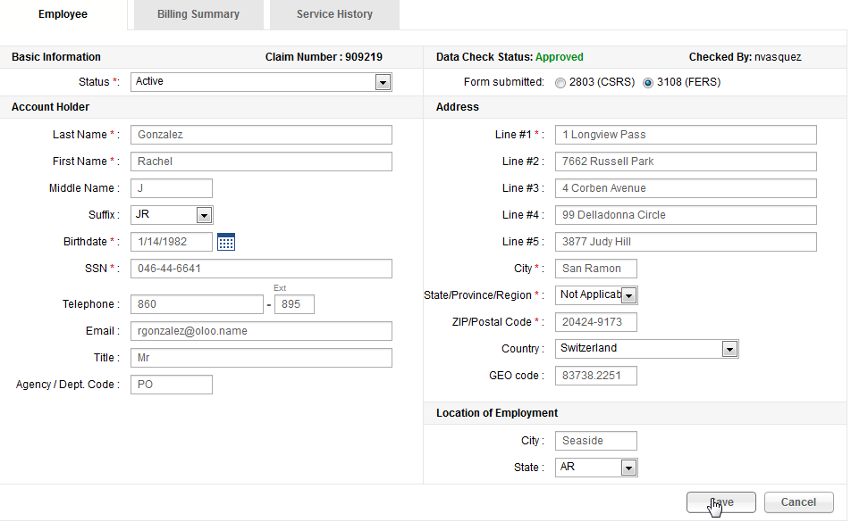

Update Interest

In the account detail page, go to Billing Summary tab.
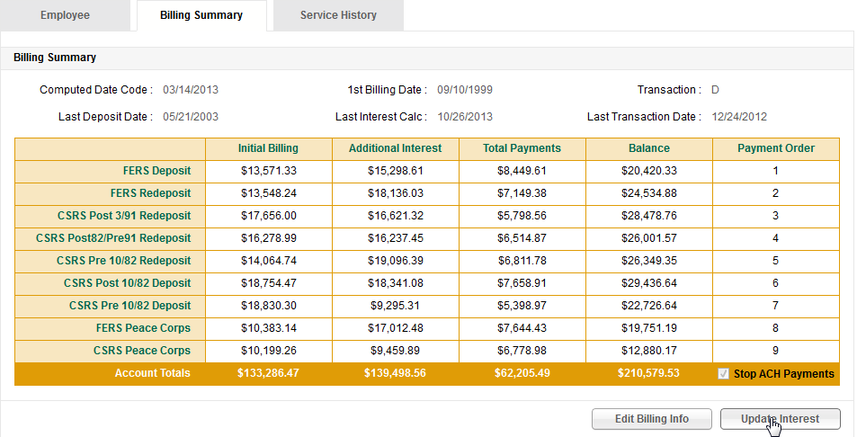
Click update Interest button, click Yes when alert box pop up.
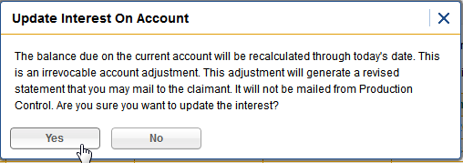
Verify a placeholder for report is displayed.
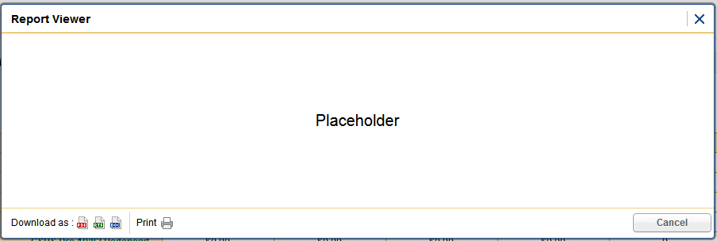
Close the report, verify the billing summary data change.
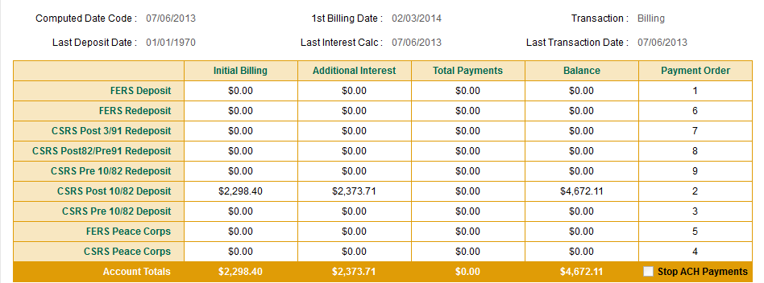

Nightly Print of Payment Statement
Click Payment Statement Print Tab.
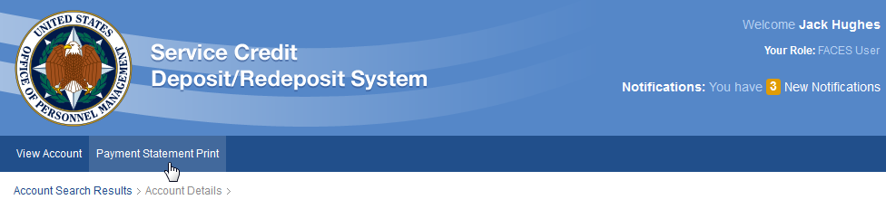
The Payment Statement Print page shows up.
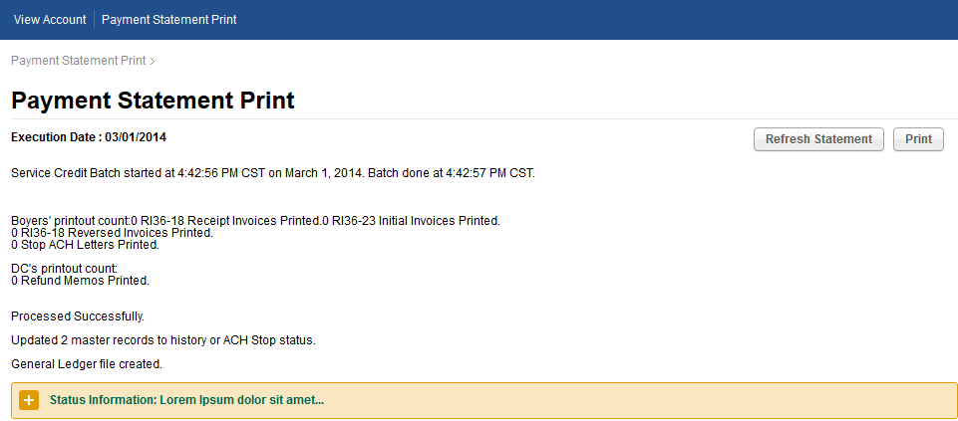
Click Print for print service.
Click “Refresh Statement” get the latest nightly payment statement

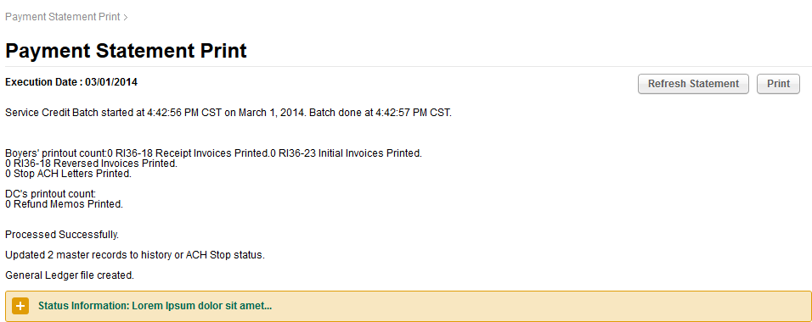

User Authorization
Login with “user2” and password “123456”, you can see there are all function are not working because user2 is not FACES user:

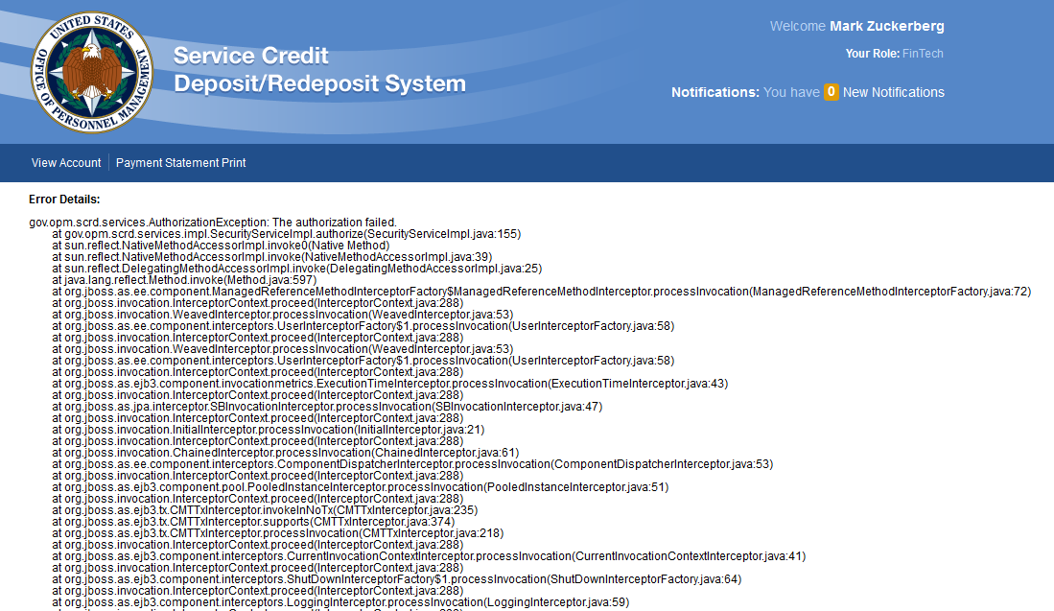

Resource Contact List

Name | Resource Email
TCSASSEMBLER

